Amazon CloudWatch
Creating a CloudWatch Dashboard
- Navigate to Amazon CloudWatch in the AWS console.
- Many AWS services automatically send metrics to CloudWatch when resources are created.
- Dashboards in CloudWatch:
  - Customizable pages to monitor multiple AWS resources.
  - Can display resources across different AWS Regions.
- Steps to create a dashboard:
  - Click Dashboards → Create dashboard.
  - Name it (e.g., mydashboard).
  - Add a widget (e.g., line graph).
  - Choose the data source → select Metrics → EC2 → Per-Instance Metrics.
  - Select CPUUtilization metric.
  - Save and view the line graph showing CPU utilization.
- This provides visibility into EC2 instance health.
- CloudWatch also supports custom metrics for deeper application monitoring.
  - Useful because instance metrics alone may not reflect actual app performance.
- Dashboards can be shared with team members.

Creating a CloudWatch Alarm
- Navigate to Alarms → Create alarm.
- Purpose: Notify if CPU utilization exceeds 70% for 5 minutes.
- Steps:
  - Select Metric → EC2 → Per-Instance Metrics → CPUUtilization.
  - Set time period to 5 minutes.
  - Set threshold to 70%.
- Alarm triggers when metric stays above the threshold for the specified time.
- Alarm States:
  - OK — metric within normal range.
  - In alarm — threshold breached.
  - Insufficient data — not enough data to determine state.
- Configure actions when alarm state changes:
  - Use Amazon SNS to send email alerts.
  - Create a new SNS topic (e.g., CPU_Utilization_Topic).
  - Add subscribers’ email addresses.
- Alarm will send an alert when transitioning from OK → In alarm.
- After creation, alarm will collect data and later move from Insufficient data → OK.
Conclusion
- CloudWatch provides monitoring, alerting, and visualization tools.
- Next steps include integrating CloudWatch with EC2 Auto Scaling for elasticity.

- AWS resources generate various types of data such as metrics, logs, network traffic, and events.
- Because AWS components are distributed, collecting this data manually can be difficult.
- Amazon CloudWatch provides a centralized platform to collect and review this data.
- CloudWatch is a monitoring and observability service that gathers resource data and provides actionable insights.
- It helps you respond to performance changes, optimize resource usage, and monitor overall system health in one unified view.
Use of CloudWatch
- Detect anomalous behavior in your environments.
- Set alarms to alert you when something is not right.
- Visualize logs and metrics with the AWS Management Console.
- Take automated actions like scaling.
- Troubleshoot issues.
- Discover insights to keep your applications healthy.
Working
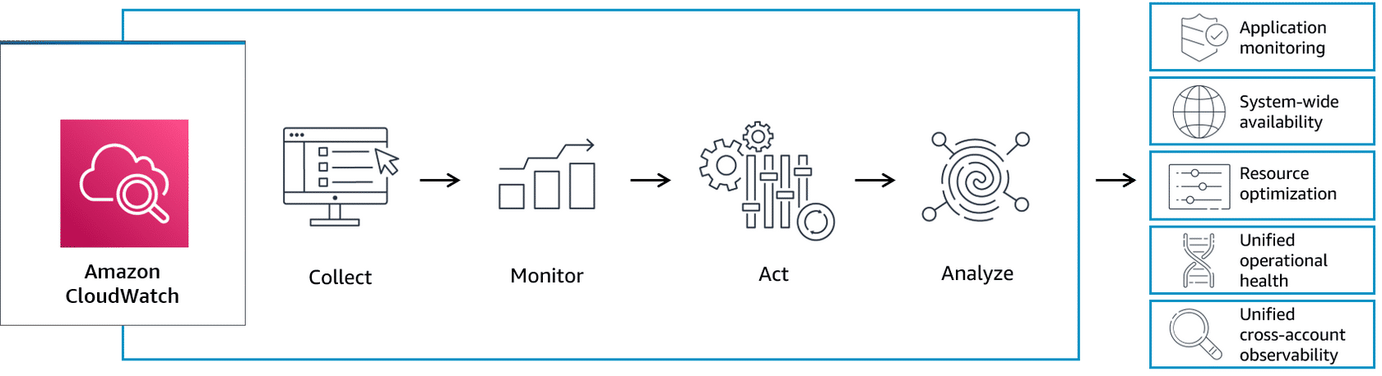
Amazon CloudWatch — the central service that collects and processes data from AWS resources and applications.
Process flow:
Collect: Gathers metrics, logs, and events from AWS services and applications.
Monitor: Tracks performance and operational data through dashboards and alarms.
Act: Responds automatically to changes (for example, triggering alarms or scaling resources).
Analyze: Examines data to gain insights, detect patterns, and improve performance.
Outcomes/Benefits:
Application monitoring – Observe app performance in real time.
System-wide availability – Ensure resources and services are running smoothly.
Resource optimization – Use resources efficiently and reduce costs.
Unified operational health – Get a complete view of your system’s status.
Unified cross-account observability – Monitor multiple AWS accounts from one place.
CloudWatch concepts
- Metrics are the core concept in Amazon CloudWatch.
- A metric is a time-ordered series of data points.
- Metrics are published to CloudWatch by AWS resources or applications.
- A metric acts like a variable that you monitor (for example, CPU utilization).
- Each data point represents the value of that variable at a specific time.
- Every data point in a metric must have an associated timestamp.
CloudWatch Log
Amazon CloudWatch Logs is a feature of CloudWatch that lets you collect, monitor, and store log files from your AWS resources, applications, and on-premises systems. It helps you troubleshoot issues, analyze behavior, and track system activity in real time.
Terminology
Event: A log event is a record of activity recorded by the application or resource being monitored. It has a timestamp and an event message.
Group: Collections of log streams that share the same settings (for example, all logs from one application).
Stream: Sequences of log events from the same source (for example, one EC2 instance).

CloudWatch Alarm
- CloudWatch alarms are used to automatically take actions based on metric state changes.
- You decide which metric to monitor and when the alarm should trigger.
- Set a threshold that defines the condition for the alarm (for example, CPU > 80%).
- Define a time period to avoid false alarms from short spikes (for example, CPU > 80% for 5 minutes).
- The alarm triggers when the metric stays above or below the threshold for the specified time.
- Once triggered, the alarm can initiate actions, such as:
  - EC2 actions (e.g., stop, start, or reboot an instance)
  - Auto Scaling actions (adjust resource capacity)
  - SNS notifications (send alerts via email or SMS)
- Alarms operate based on state transitions:
  - OK – metric is within the normal range.
  - ALARM – metric has crossed the threshold.
  - INSUFFICIENT_DATA – not enough data to determine the state.
Resources
For more information, see the following resources:
- AWS website: Amazon CloudWatch Pricing(opens in a new tab)
- AWS website: Amazon CloudWatch(opens in a new tab)
- AWS user guide: Getting Started with Amazon CloudWatch(opens in a new tab)
- AWS user guide: What Is Amazon CloudWatch Logs?(opens in a new tab)
- AWS user guide: AWS services that publish CloudWatch metrics(opens in a new tab)
- AWS user guide: View available metrics(opens in a new tab)
- AWS website: Amazon SNS

